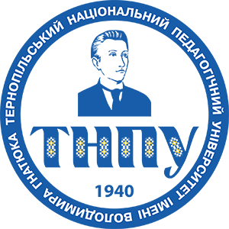
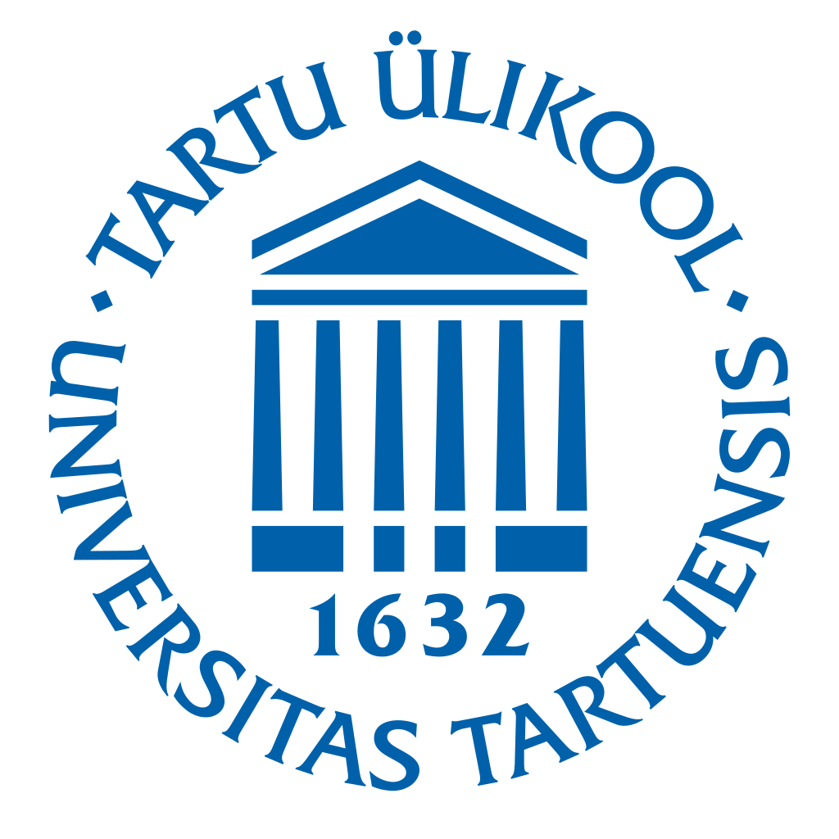
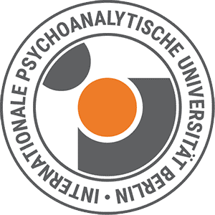
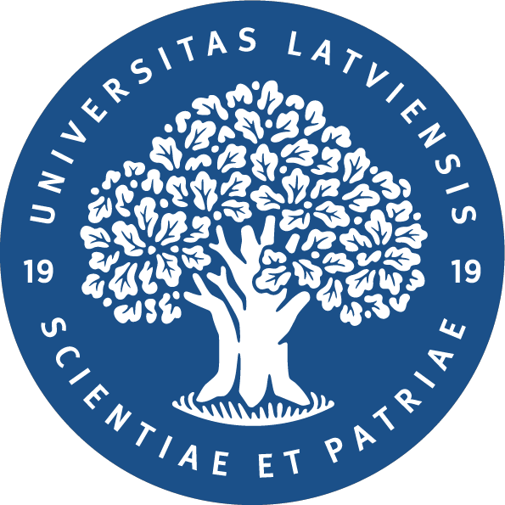

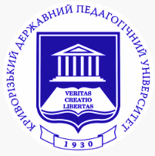
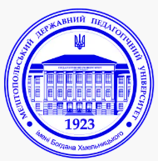


Trauma-Informed Approaches to Mental Health Support and Resilience Building in Times of Societal Crises

International Scientific and Practical Conference



Final International Dissemination Conference

of the Erasmus+ Capacity Building in Higher Education (CBHE) Project

BURN – Boosting University Psychological Resilience

and Wellbeing in the (Post-)War Ukrainian Nation

28–29 September 2026

Hosted by Ternopil Volodymyr Hnatiuk National Pedagogical University, Ukraine
Co-organised by Kryvyi Rih State Pedagogical University, Ukraine,
in cooperation with all partners of the Erasmus+ CBHE BURN Consortium

Conference Overview

The International Scientific and Practical Conference is organised within the framework of the Erasmus+ Capacity Building in Higher Education (CBHE) project BURN – Boosting University Psychological Resilience and Wellbeing in the (Post-) War Ukrainian Nation and serves as its final international dissemination event.
The conference aims to present the key achievements and outcomes of the BURN project, promote the exchange of knowledge and good practices, and strengthen cooperation between Ukrainian and European higher education institutions in the field of trauma-informed education, mental health, psychosocial support, and resilience.
Over the course of the project, the consortium has developed innovative educational programmes, established Psychological Resilience Centres, strengthened the professional competencies of university staff and mental health specialists, and enhanced institutional capacity to provide trauma-informed support within higher education. The conference offers a platform to showcase these achievements, discuss current research and practical experience, and identify future directions for international cooperation and sustainable development.
The conference brings together researchers, psychologists, psychotherapists, educators, social workers, healthcare professionals, representatives of civil society organisations, policymakers, and international experts committed to advancing mental health, wellbeing, and resilience in times of war, forced displacement, and other societal crises.

Conference Objectives
The conference aims to:
- disseminate the achievements and best practices of the Erasmus+ CBHE BURN project;
- present innovative educational approaches and training methodologies developed within the project;
- facilitate interdisciplinary dialogue on trauma-informed education, mental health, and psychosocial recovery;
- strengthen cooperation between Ukrainian and European higher education institutions and project partners;
- promote the sustainable development of the Psychological Resilience Centres established within the BURN project;
- explore future opportunities for international collaboration in higher education, mental health, and resilience building.

Conference Themes

- Achievements and impact of the Erasmus+ CBHE BURN project: educational innovation, Psychological Resilience Centres, capacity building, and international cooperation;
- Trauma-informed approaches in higher education and professional training;
- Mental health support during war, forced displacement, and post-war recovery;
- Individual, community, and institutional resilience;
- Mental health and psychosocial support for children, young people, veterans, and other vulnerable populations;
- Educational practices promoting psychological wellbeing and resilience;
- Contemporary psychotherapeutic and psychosocial interventions;
- Innovative technologies and interdisciplinary approaches to mental health support and recovery.

Conference Programme

Trauma-Informed Approaches and Capacity Building in Higher Education
28 September 2026

Day 1

Time | Session | Speaker(s) / Details | Format / Language
09:00–09:45 | Opening Ceremony | Welcome Addresses  Bogdan Buyak, Rector, Ternopil Volodymyr Hnatiuk National Pedagogical University  Yaroslav Shramko, Rector, Kryvyi Rih State Pedagogical University  Svitlana Shytikova, Coordinator of the National Erasmus+ Office – Ukraine  Project Presentation  Erasmus+ CBHE BURN: Achievements, Impact and Future Perspectives – Iryna Zadorozhna, Project Coordinator.  Conference Programme Overview – Representative of Kryvyi Rih State Pedagogical University | Hybrid  English / Ukrainian translation  https://us02web.zoom.us/j/83286181094?pwd=9zGTpWRKpMHZiyYBIiub9OB4zU7rfr.1  Meeting ID: 832 8618 1094  Passcode: 998682
09:45–10:30 | Keynote Lecture | Countertransference in the Context of Posttraumatic Stress — Prof. Dr. Lutz Wittmann, Professor of Clinical Psychology and Psychotherapy, International Psychoanalytic University Berlin, Germany | Hybrid / English with Ukrainian translation  https://us02web.zoom.us/j/83286181094?pwd=9zGTpWRKpMHZiyYBIiub9OB4zU7rfr.1
10:30–10:50 | Discussion & Q&A | Discussion of the keynote lecture | Hybrid  English / Ukrainian translation  https://us02web.zoom.us/j/83286181094?pwd=9zGTpWRKpMHZiyYBIiub9OB4zU7rfr.1
10:50–11:10 | Coffee Break
11:10–11:50 | International Round Table | Trauma-Informed Interventions in the Context of War and Forced Displacement. Moderator: Prof. Iryna Zadorozhna.  Speakers: Prof. D.Sc. Iuliia Pavlova;  Dr. Kateryna Bondar; Prof. Anzhelika Kolli-Shamne | Online / Ukrainian  https://us02web.zoom.us/j/83286181094?pwd=9zGTpWRKpMHZiyYBIiub9OB4zU7rfr.1
11:50–12:10 | Discussion & Q&A | Discussion of the round table | Online / Ukrainian  https://us02web.zoom.us/j/83286181094?pwd=9zGTpWRKpMHZiyYBIiub9OB4zU7rfr.1
12:10–13:15 | Lunch Break
Parallel BURN workshops
13:15–15:15 | Interactive Workshop A | From Witness to Change Maker: From Collective Trauma to Collective Resilience — Olesia Prokofieva, PhD, Associate Professor, Psychodrama Therapist. Pre-registration required; maximum 20–25 participants. | Offline / Ukrainian
13:15–15:00 | InteractiveWorkshop B | Biofeedback Technologies and Somatic Stabilisation as Tools of Psychological First Aid in Academic Settings — Olena Shestopalova & Tetiana Shevchenko | Hybrid / Ukrainian  https://us04web.zoom.us/j/74430125407?pwd=3smaIyupM9JLOQMgyiGIfI1fGgaUpY.1  Meeting ID: 744 3012 5407  Passcode: 1U37nJ
15:00–15:25 | Coffee Break
15:25–17:00 | InteractiveWorkshop C | Internal Conflicts: Finding a Path to Wholeness — Valentyna Zarytska, D.Sc., Professor. | Online / Ukrainian
15:25–17:00 | Interactive Workshop D | A Contemporary Perspective on Psychological Recovery: Communication as a Source of Growth — Olesia Andriivna Yesina, Trainee Lecturer, PhD Student, Specialist at the Centre for Psychological Resilience and Well-being | Offline / Ukrainian  https://us02web.zoom.us/j/7831532645?pwd=CBIIpDfv7a68FKrydqV4sqfea34q27.1  Meeting ID: 783 153 2645  Passcode: Psy
17:10 | Summary of Day 1 | Conference reflections and summary | Online / Ukrainian  https://kdpu-edu-ua.zoom.us/j/4255365651?pwd=UDAwWklhakNtMi9FdU1neDFPSUZwQT09

Trauma-Focused Approaches and

Psychosocial Recovery
29 September 2026

Day 2
Time | Session | Speaker(s) / Details | Format / Language
10:00–10:40 | Keynote Lecture | Peer Supervision as Psychosocial Support for Mental Health Professionals in War and Crisis Settings — Sharipha Rzayeva, Psychologist, Tartu Counselling Centre, University of Tartu, Estonia | Hybrid / English with Ukrainian translation  Zoom link:  https://us02web.zoom.us/j/83286181094?pwd=9zGTpWRKpMHZiyYBIiub9OB4zU7rfr.1  Meeting ID: 832 8618 1094  Passcode: 998682
10:45–11:15 | Keynote Lecture | Jean Monnet Project: “Socio-Psychological Aspects of European Values under Martial Law in Ukraine” — Oxana Bayer, PhD, Associate Professor, Alfred Nobel University, Dnipro | Hybrid / English with Ukrainian translation  https://us02web.zoom.us/j/83286181094?pwd=9zGTpWRKpMHZiyYBIiub9OB4zU7rfr.1
11:15–11:30 | Coffee Break
Parallel BURN workshops
11:30–12:30 | Parallel Workshop A | “Eye of the Storm”: A Guided Self-Help and Psychological Intervention Programme for Reducing the Effects of Chronic Stress on the Sexual Health of AFAB Individuals — Olena Charkina & Yelyzaveta Sovenko | Online / Ukrainian  https://us04web.zoom.us/j/4092567381?pwd=sydmKCzyXW2Kgby83dq9ISLejbb7zO.1&omn=75759547678
11:30–12:30 | Parallel Workshop B | Cultivating Resilience — Zoriana Adamska & Zoriana Zaterta | Offline / Ukrainian
11:30–12:30 | Parallel Workshop С | Trauma-Informed Practice as a Meta-Competence for Today’s Educators - Yemets Daria | Online / Ukrainian  https://us02web.zoom.us/j/83286181094?pwd=9zGTpWRKpMHZiyYBIiub9OB4zU7rfr.1
12:30–13:30 | Lunch Break
13:30–14:30 | Parallel Workshop D | “Spread Your Wings”: A Transformational Psychological Game as a Tool for Developing Personal Resources and Resilience — Svitlana Shevchenko & Hanna Varina | Online / Ukrainian  https://us02web.zoom.us/j/5680983177?pwd=U0bB49cufTFwbJWAvbNotsu4JXK02t.1  Meeting ID: 568 098 3177  Passcode: 933192
13:30–14:30 | Parallel Workshop E | Renewing Life’s Meaning — How to Live Without Regret — Tetiana Borozentseva & Kateryna Zhurbyliuk | Offline / Ukrainian
13:30–14:30 | Parallel Workshop F | Rediscovering Strength — Art Therapy for Post-Traumatic Recovery — Nataliia Kosheleva | Online / Ukrainian  https://forlan-org-ua.zoom.us/j/89773979059
14:30–14:50 | Coffee Break
14:50–15:20 | Poster Session | Psychological Resilience Centres Established within the Erasmus+ CBHE BURN Project — presentations by BURN project partners | Hybrid  English / Ukrainian translation  https://us02web.zoom.us/j/83286181094?pwd=9zGTpWRKpMHZiyYBIiub9OB4zU7rfr.1
15:20–16:00 | Closing Panel | Sustainability of the Erasmus+ CBHE BURN Project: Results, Future Cooperation and Institutional Development. Conference Resolution and Closing Remarks | Hybrid / English with Ukrainian translation  https://us02web.zoom.us/j/83286181094?pwd=9zGTpWRKpMHZiyYBIiub9OB4zU7rfr.1

International Round Table — Speakers
Speaker | Affiliation / Expertise
Prof. D.Sc. Iuliia Pavlova | Full Professor, Ivan Boberskyj Lviv State University of Physical Culture; Co-Director, Cochrane Ukraine; researcher in youth mental health, resilience and wellbeing in wartime Ukraine
Dr. Kateryna Bondar | PhD, Associate Professor, Kryvyi Rih State Pedagogical University; researcher in international trauma-informed support for children in Ukraine, Poland and Sweden
Prof. Anzhelika Kolli-Shamne | Professor, Kherson State University; Doctor of Psychological Sciences

Poster Session — BURN Psychological Resilience Centres
Institution
Ternopil Volodymyr Hnatiuk National Pedagogical University
Kryvyi Rih State Pedagogical University
Bogdan Khmelnitsky Melitopol State Pedagogical University
Horlivka Institute for Foreign Languages of Donbas State Pedagogical University
Kherson State University

Closing Panel — Institutional Partners
Panel
Ternopil Volodymyr Hnatiuk National Pedagogical University
Kryvyi Rih State Pedagogical University
Kherson State University
Bogdan Khmelnitsky Melitopol State Pedagogical University
Horlivka Institute for Foreign Languages of Donbas State Pedagogical University
International Psychoanalytic University Berlin, Germany
University of Tartu, Estonia
University of Latvia, Latvia

